
STUDENT CASE STUDY EXECUTION REPORT
Department | CSE
Subject | DSA-2
Academic Year | I-III Semester (2025-26)
Faculty Name | Dr.N.Chaitanya Kumar
Student Name | CH SAI PRASANNA
Roll number | 2520030608
Branch | CSE
Course Outcome | CO-2

Case Study Topic: AgroChain Agricultural Supply Network Analysis using Segment Tree, Fenwick Tree, BFS, DFS, Prim's and Kruskal's Algorithms
Work Done Summary:
In this case study, an Agricultural Supply Network Analysis System was developed for the AgroChain platform. The system analyzes crop production statistics and transportation connectivity between farms, warehouses, and markets. Segment Trees and Fenwick Trees were used for efficient production data analysis, while BFS, DFS, Prim's, and Kruskal's algorithms were applied to optimize agricultural transportation networks.
Implementation Details:
- Implemented Segment Tree for efficient range production queries.
- Implemented Fenwick Tree for cumulative production calculations.
- Applied BFS traversal to analyze network connectivity.
- Applied DFS traversal to explore transportation routes.
- Implemented Prim's Algorithm to generate minimum-cost transportation networks.
- Implemented Kruskal's Algorithm to optimize supply chain routes.
- Compared MST costs generated by Prim's and Kruskal's algorithms.

Result: Output :
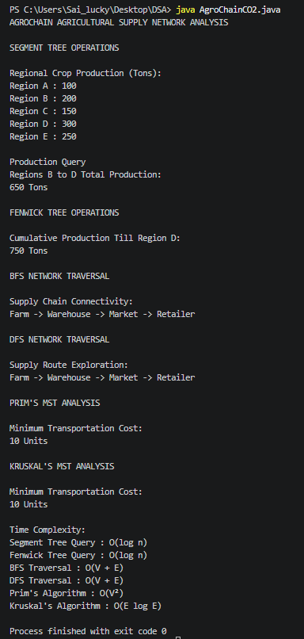
The AgroChain Agricultural Supply Network Analysis System successfully analyzed crop production data and transportation connectivity using Segment Trees, Fenwick Trees, BFS, DFS, Prim's, and Kruskal's algorithms.
Time Complexity:
- Segment Tree Query : O(log n)
- Fenwick Tree Query : O(log n)
- BFS Traversal : O(V + E)
- DFS Traversal : O(V + E)
- Prim's Algorithm : O(V²)
- Kruskal's Algorithm : O(E log E)
The implemented algorithms efficiently analyzed supply chain connectivity and optimized transportation routes with minimum cost.

GitHub Link:
https://github.com/PRASANNA18-sai/AgroChain-Smart-Agriculture-Supply-Chain-Management-System

Student Signature | Faculty Signature
________________________ | __________________________

